**Alekhya Krishna Balivada SQL Day 6 Assessment-6(09-12-2023)**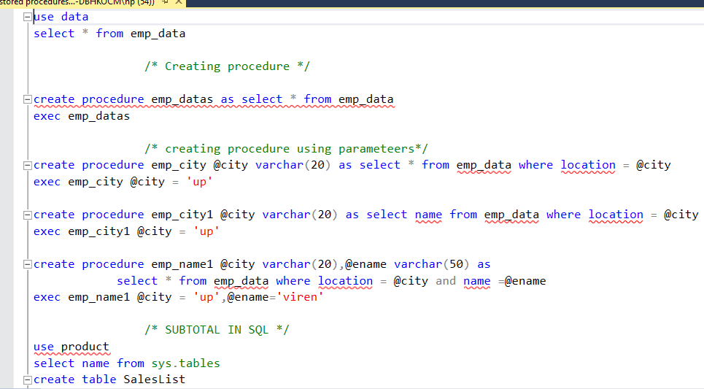

**Creating and executing procedures using single and multiple parameters**

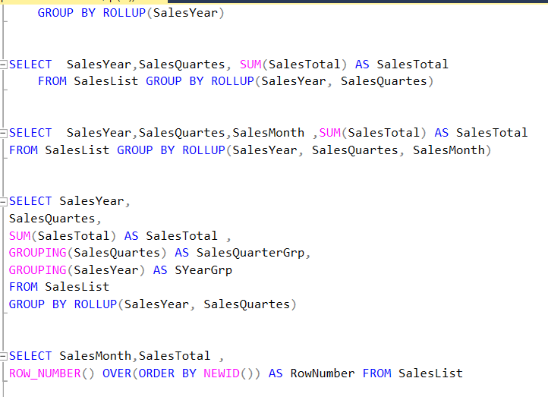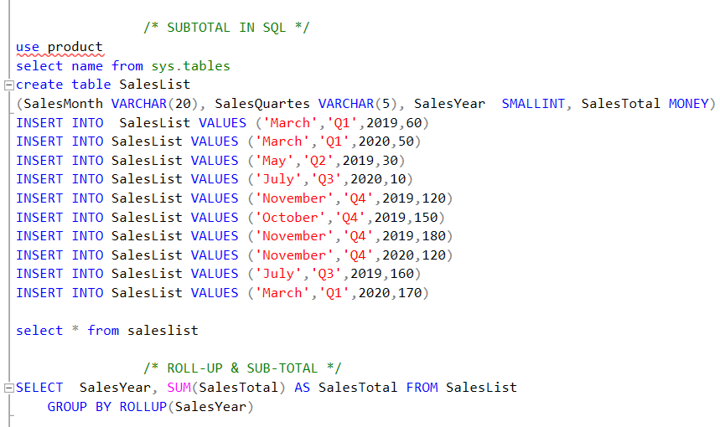**Getting sub-total of sales using group by and roll-up**